Persistent Effects and Handoff — Lesson Plan
Classification: UNCLASSIFIED

1. Administrative and metadata

1.1 Lesson title
Persistent Effects and Handoff

1.2 Module length
60 minutes (1 hours)
Schedule slot is 60 minutes. Content-guide ~60 minutes matches that slot.

1.3 Terminal and enabling learning objectives
- TLO-3: At the end of the Counterstrike Operator Course, students will be able deny adversary ability to accomplish their mission in cyberspace.
- TLO-4: At the end of the Counterstrike Operator Course, students will be able to rapidly access and effect adversary infrastructure
- ELO-58: Evaluate the effectiveness of selected and sequenced MITRE ATT&CK impact techniques in accomplishing military tactical tasks.
- ELO-81: Communicate planned effects using terminology from US joint military doctrine.
- ELO-82: Given access to adversary infrastructure, execute a bounded effect while preserving collection and attribution discipline.

1.4 Prerequisites
- B04.M21: Poison Harvest Collection

2. Personnel, range, and environment

2.1 Instructor and cadre
- 1 × instructor (required)
- 0 × range_engineer (not_applicable: Lecture Module; no range engineer required)
- 0 × auditor (not_applicable: Not used by this course)
- 0 × oversight_officer (not_applicable: Not used by this course)

2.2 Materials and resources
Instructor resources and pre-class preparation
- Classroom projector and screen; whiteboard for the opening contract
- Parent or sibling briefs listed in this Module folder
- Live tabs and references already named in this file's header
- Do not project flags, tokens, or answer-key values
Student resources and environment
- Student brief, student guide, or homework file in this Module folder when present
- Assigned range, workstation, or lab stack named in the student-facing file
- No extra kit beyond what the student-facing file already lists

3. Assessment and evaluation
ELO | Method | Related Module | Criteria
ELO-58 | in-class Q&A | — | In-class questions and check on learning in the content guide.
ELO-81 | in-class Q&A | — | In-class questions and check on learning in the content guide.
ELO-82 | in-class Q&A | — | In-class questions and check on learning in the content guide.

4. Instructional delivery

4.1 Opening, attention grabber, and motivator

Option 1 (Interactive / Whiteboard / Kinesthetic)
- Say: "Yesterday you produced effects that lived and died inside the adversary stack. Today you reach out past that stack. Survey is how you execute reconnoiter in practice — you collect technical and behavioral facts from the adversary workflow and turn them into pursuit-enabling intelligence. Handoff deploys another team's capability from your foothold when needed — that is a force-multiplier. These are the effects that make a CPT valuable outside its own enclave."
- Do: Put the lesson contract on the board. Keep products from the prerequisite Module available.
- Ask (Q): At your home unit, where does a partner team usually get stuck first: incomplete technical detail, unclear behavioral context, or both?
- Expected Response (A): Facilitation. Use the Say/Do already on this row; do not force a single keyed answer.

Option 2 (Digital Slide / Virtual / Slide Deck)
- Say: "Yesterday you produced effects that lived and died inside the adversary stack. Today you reach out past that stack. Survey is how you execute reconnoiter in practice — you collect technical and behavioral facts from the adversary workflow and turn them into pursuit-enabling intelligence. Handoff deploys another team's capability from your foothold when needed — that is a force-multiplier. These are the effects that make a CPT valuable outside its own enclave."
- Show: The title slide and lesson objectives.
- Do: Confirm stations can open the required tool or file before the first teaching row.
- Ask (Q): At your home unit, where does a partner team usually get stuck first: incomplete technical detail, unclear behavioral context, or both?
- Expected Response (A): Facilitation. Use the Say/Do already on this row; do not force a single keyed answer.

4.2 Side-by-side table of instruction
Visual / Slide Asset | Instructional Delivery & Instructor Notes
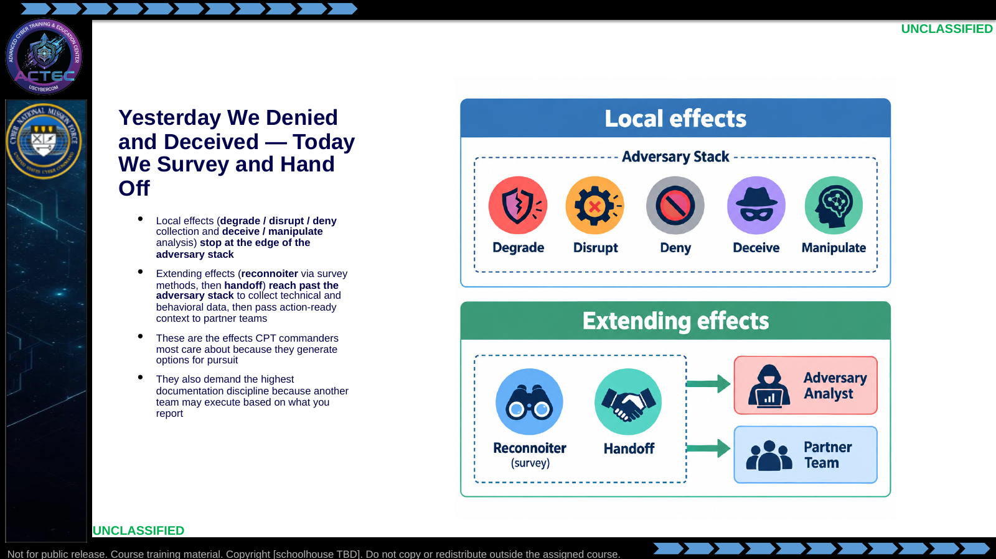  Slide 1: Yesterday We Denied and Deceived — Today We Survey and Hand Off  Duration: 8 min | Say: "Yesterday you produced effects that lived and died inside the adversary stack. Today you reach out past that stack. Survey is how you execute reconnoiter in practice — you collect technical and behavioral facts from the adversary workflow and turn them into pursuit-enabling intelligence. Handoff deploys another team's capability from your foothold when needed — that is a force-multiplier. These are the effects that make a CPT valuable outside its own enclave."  Show: The local-vs-extending graphic.  Do: Ask: "At your home unit, where does a partner team usually get stuck first: incomplete technical detail, unclear behavioral context, or both?" Use answers to frame why today's reporting quality matters.  Ask (Q): At your home unit, where does a partner team usually get stuck first: incomplete technical detail, unclear behavioral context, or both?  Expected Response (A): Facilitation. Use the Say/Do already on this row; do not force a single keyed answer.
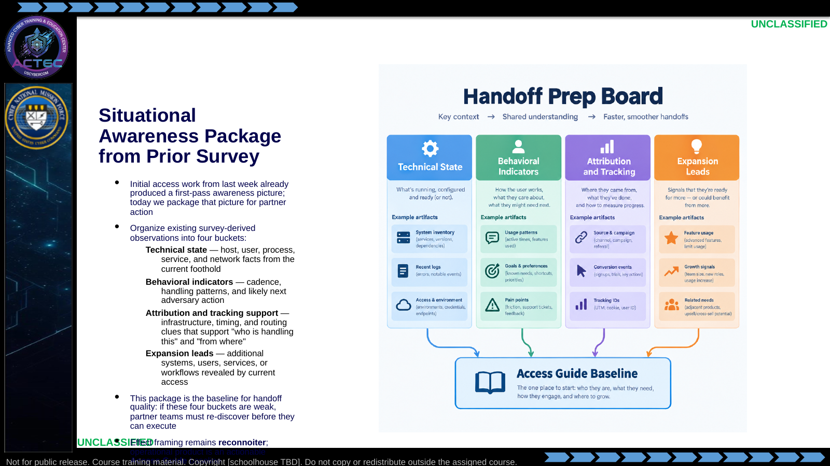  Slide 2: Situational Awareness Package from Prior Survey  Duration: 8 min | Say: "Do not treat this as raw log dump. Treat it as your situational awareness package from prior survey work. Four buckets: technical state, behavior, attribution-and-tracking, and expansion leads. This is what partners need first to decide if they can act now, need more evidence, or need you to collect additional detail before handoff."  Show: The four-column package graphic; walk one concrete example in each column and map it to Access Guide fields.  Do: Ask: "Which of these four buckets is usually weakest in your team handoffs, and what mission risk does that create?"  Ask (Q): Which of these four buckets is usually weakest in your team handoffs, and what mission risk does that create?  Expected Response (A): Facilitation. Use the Say/Do already on this row; do not force a single keyed answer.
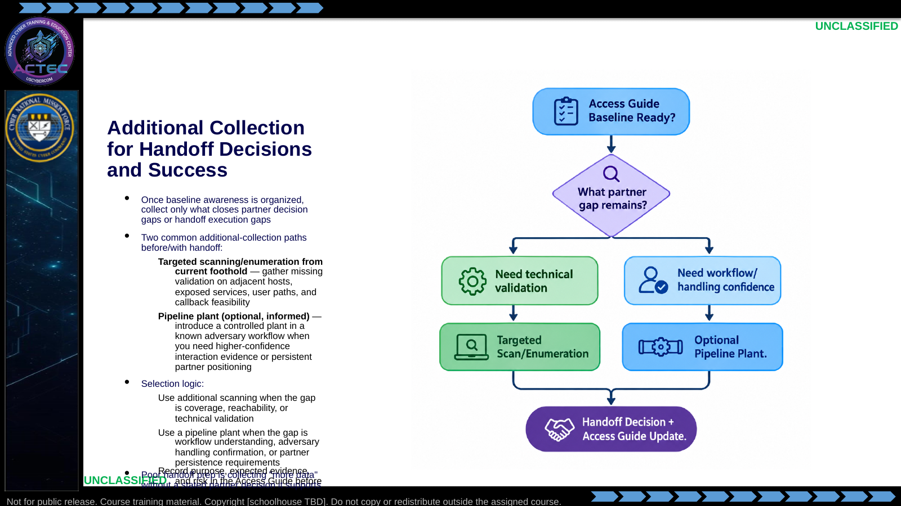  Slide 3: Additional Collection for Handoff Decisions and Success  Duration: 8 min | Say: "Slide 2 gave the baseline. This slide is the gap-closure step. Ask what the partner still cannot decide or execute. If the gap is technical validation, scan with purpose. If the gap is workflow confidence or persistent positioning, consider a pipeline plant. In both cases, tie every action to a partner decision and capture it in the guide."  Show: The decision flow and one example gap routed down each branch.  Do: Ask: "Name one handoff decision your partner cannot make yet, then pick scan or plant and defend your choice in one sentence."  Ask (Q): Name one handoff decision your partner cannot make yet, then pick scan or plant and defend your choice in one sentence.  Expected Response (A): Facilitation. Use the Say/Do already on this row; do not force a single keyed answer.
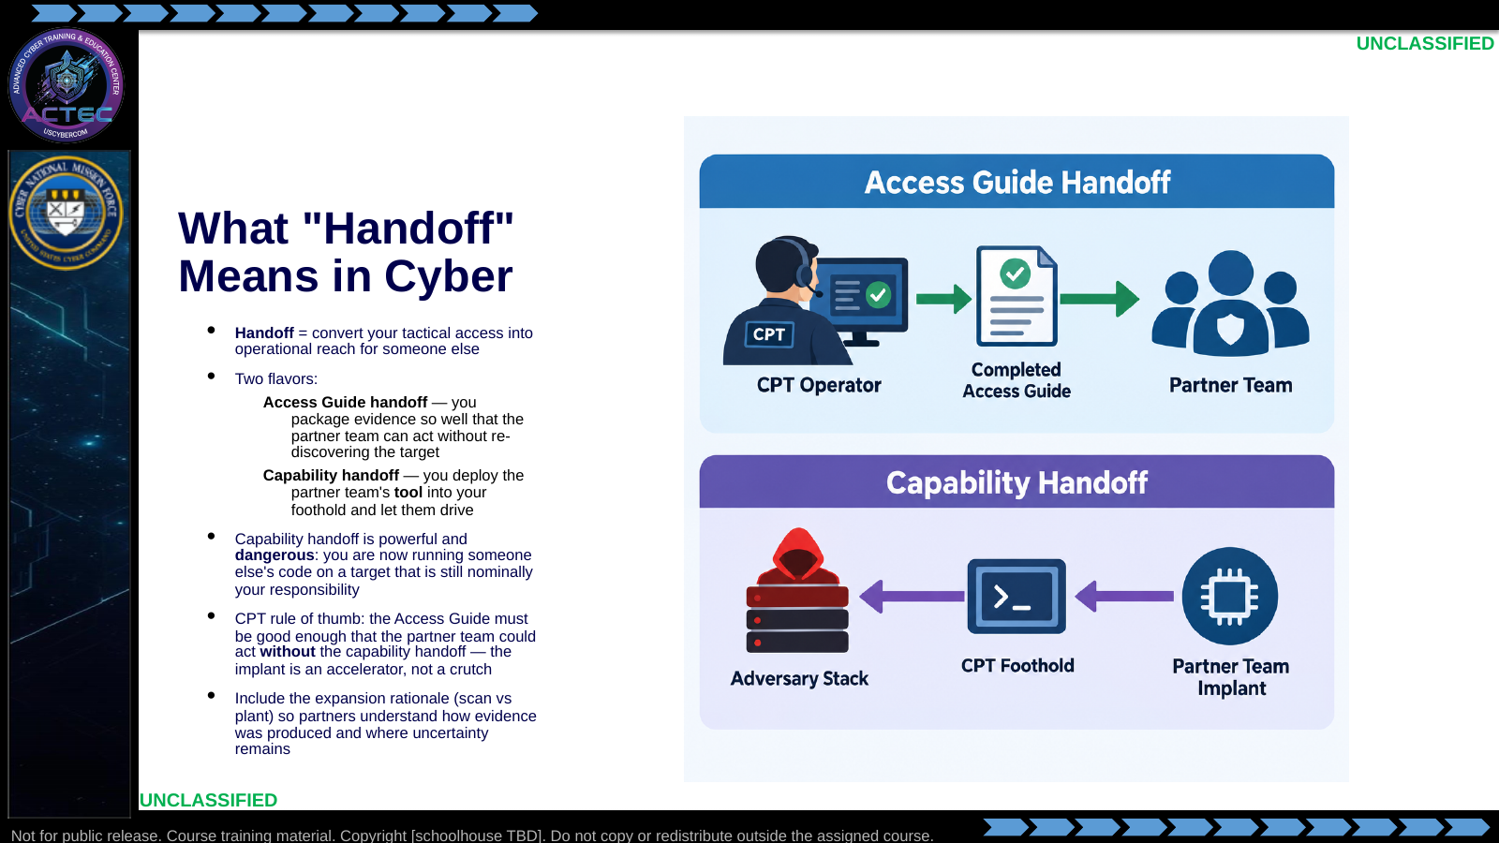  Slide 4: What "Handoff" Means in Cyber  Duration: 8 min | Say: "Handoff has two shapes. Access Guide handoff is you writing technical and behavioral context so clearly that another team can execute immediately. Capability handoff is you taking that team's tool and planting it in the position you already hold. Always produce the Access Guide first; only add capability handoff when partner mission need requires it."  Show: The two-lane diagram; linger on "Access Guide first, capability second."  Do: Ask: "If a partner receives only tool access but no Access Guide, what planning errors are most likely in the first 10 minutes?" Use answers to reinforce why guide quality comes first.  Ask (Q): If a partner receives only tool access but no Access Guide, what planning errors are most likely in the first 10 minutes?  Expected Response (A): Facilitation. Use the Say/Do already on this row; do not force a single keyed answer.
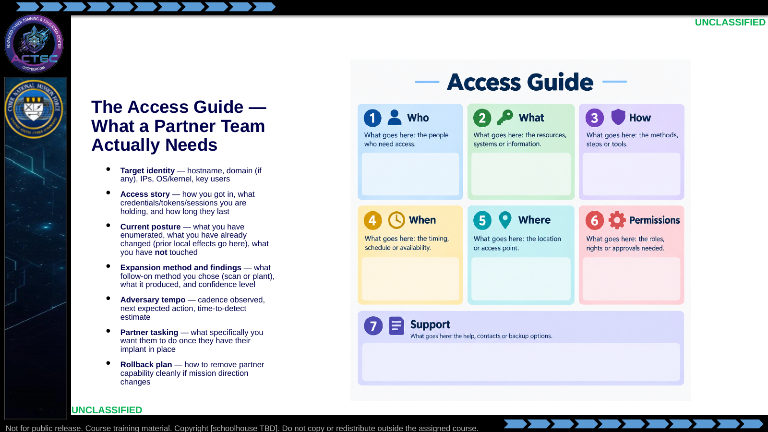  Slide 5: The Access Guide — What a Partner Team Actually Needs  Duration: 8 min | Say: "Write this template down. You will fill it in when you produce a partner Access Guide. This is not paperwork for its own sake — these seven sections are the questions a partner team will ask you in a five-minute sync call. If you cannot answer them crisply, they will not take the handoff, or worse, they will take it and do something you did not expect. The rollback plan is the section people skip and regret."  Show: The seven-section template.  Do: On the whiteboard, start a blank handoff template using the current foothold as the example target. Have the room call out what goes in each section. Tell them later Access Guide work will grade them against this template.  Ask (Q): What is the operational takeaway from this row?  Expected Response (A): Facilitation. Restate the Say/Do in operator terms. Do not invent a new teaching point.
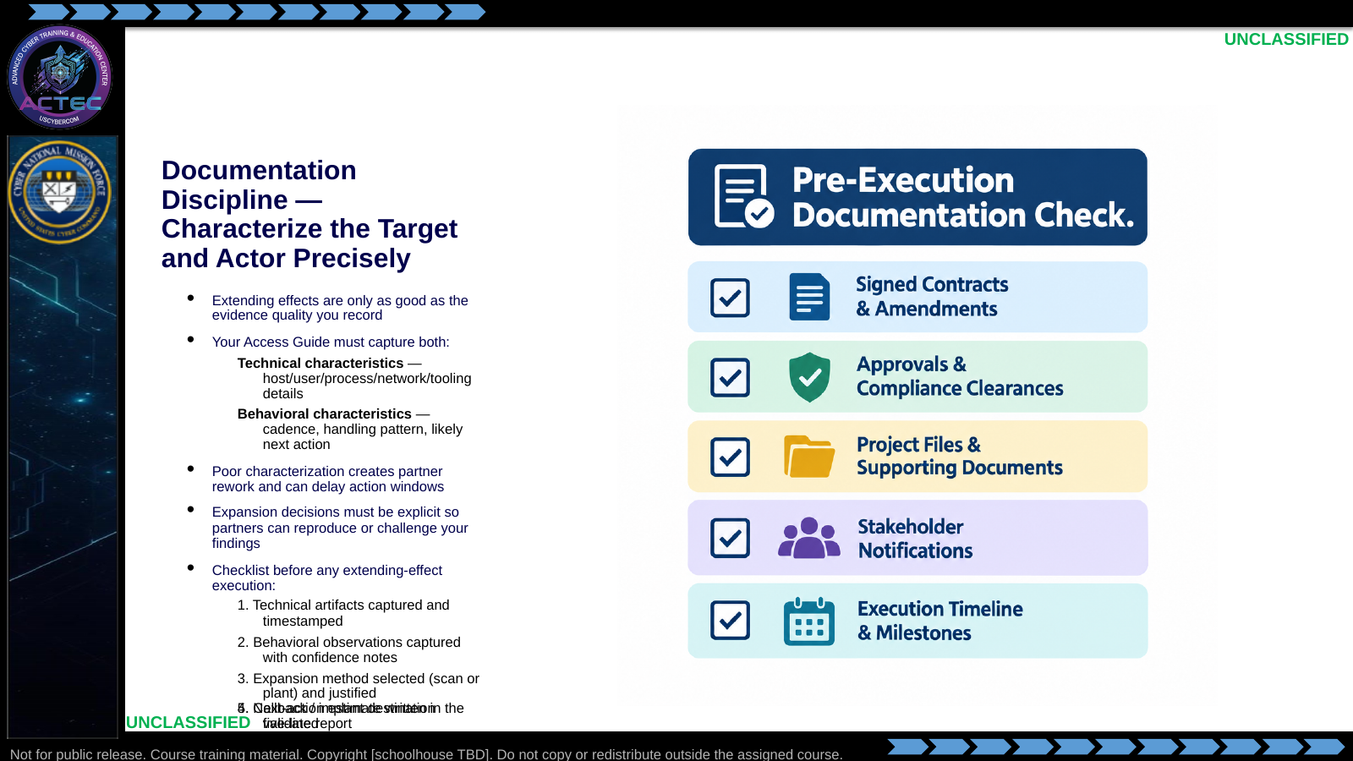  Slide 6: Documentation Discipline — Characterize the Target and Actor Precisely  Duration: 8 min | Say: "Today I am grading your characterization quality. A partner team acts on what you documented, not on what you meant. If technical artifacts are incomplete, behavioral observations are vague, or your expansion method is unexplained, you force rediscovery and lose tempo. Five-item check: technical evidence, behavioral evidence, method justification, validated destination, and next-action estimate. If any one is missing, stop and complete the record first."  Show: The checklist graphic with the red header.  Do: Run a dry check: pick one student at random, give them a notional action ("deploy the partner RAT to adv-c2"), and have them read the five-item documentation check aloud against it. Correct any missing items.  Ask (Q): What is the operational takeaway from this row?  Expected Response (A): Facilitation. Restate the Say/Do in operator terms. Do not invent a new teaching point.
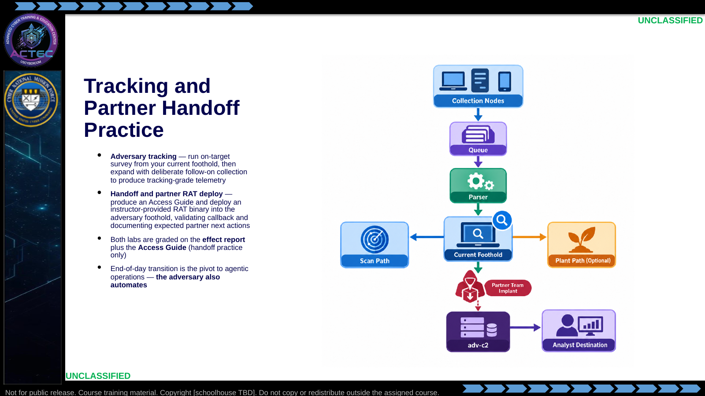  Slide 7: Tracking and Partner Handoff Practice  Duration: 8 min | Say: "Two practices, both in extending territory. Tracking starts with on-target survey and then deliberate expansion. Handoff is a live implant plus a complete Access Guide. Later this Block, the adversary runs these same playbooks with SI help."  Show: The annotated stack diagram.  Do: Hand out the adversary-tracking student brief. Remind them that precision in collection and reporting is graded, not just successful callback. Break 15 minutes, then release to the lab.  Ask (Q): What is the operational takeaway from this row?  Expected Response (A): Facilitation. Restate the Say/Do in operator terms. Do not invent a new teaching point.
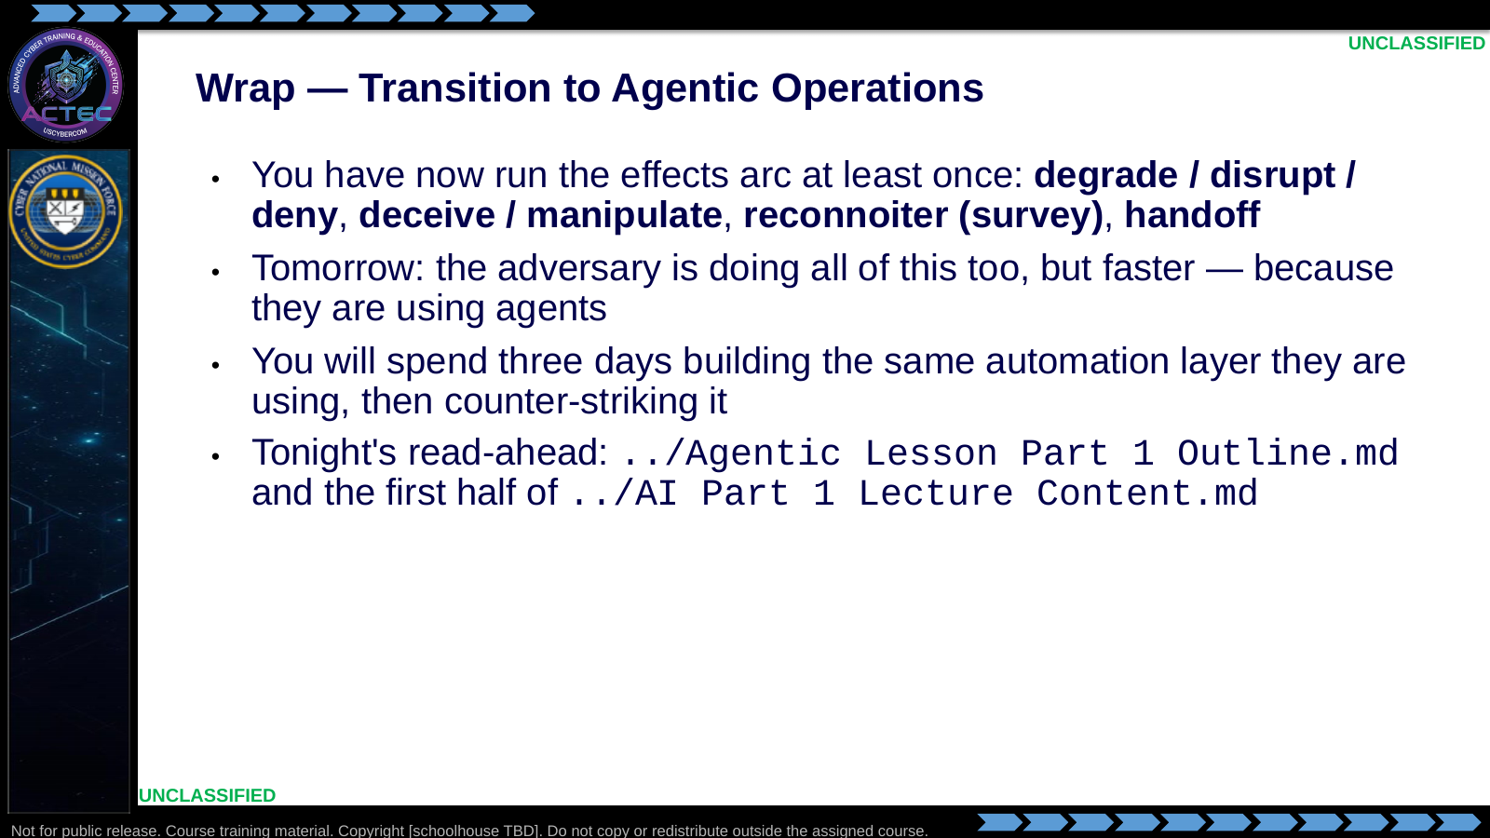  Slide 8: Wrap — Transition to Agentic Operations  Duration: 8 min | Say: "Look at what you ran in two days. Deny-or-degrade language on collection, deception on their analysis, reconnoiter via disciplined survey, then handoff when partners need to execute at tempo. One adversary stack. Human-paced. Now imagine an adversary running the same arc against you with a local LLM picking targets, tool-calling into your environment, and rewriting its own C2 on the fly. That is what later adversary-agent practice ends against. The only way you get good at defeating that is to build one first — which is what the next lectures start."  Show: A simple four-box checklist labeled with the four doctrinal buckets from the slide bullets; check them all.  Do: Collect the five-line effect reports and handoff packages. Tell students these reports become later retrieval context — their own work becomes the agent's knowledge base. Dismiss.  Ask (Q): What is the operational takeaway from this row?  Expected Response (A): Facilitation. Restate the Say/Do in operator terms. Do not invent a new teaching point.

4.3 Lesson summary
- B04.M09-persistent-effects-handoff is executed as a generated lesson plan from this file.
- Assessment methods live on module.yaml; do not invent extra official ELOs.
- Later practice in this Block continues from the product this session collects.

4.4 Questions and check on learning
- Ask (Q): At your home unit, where does a partner team usually get stuck first: incomplete technical detail, unclear behavioral context, or both?
- Expected Response (A): Facilitation. Use the Say/Do already on this row; do not force a single keyed answer.
- Ask (Q): Which of these four buckets is usually weakest in your team handoffs, and what mission risk does that create?
- Expected Response (A): Facilitation. Use the Say/Do already on this row; do not force a single keyed answer.
- Ask (Q): Name one handoff decision your partner cannot make yet, then pick scan or plant and defend your choice in one sentence.
- Expected Response (A): Facilitation. Use the Say/Do already on this row; do not force a single keyed answer.

5. Classification
Classification: UNCLASSIFIED

